**STEPPER MOTOR**

A stepper motor is an electric motor whose main feature is that its shaft rotates by performing steps, that is, by moving by a fixed amount of degrees.

## Stepper Motor Working Principles

 As all with electric motors, stepper motors have a stationary part (the stator) and a moving part (the rotor). On the stator, there are teeth on which coils are wired, while the rotor is either a [permanent magnet](https://www.monolithicpower.com/en/energy-recycling-in-dc-motor-drives) or a variable reluctance iron core. We will dive deeper into the different rotor structures later. **Figure 1** shows a drawing representing the section of the motor is shown, where the rotor is a variable-reluctance iron core.

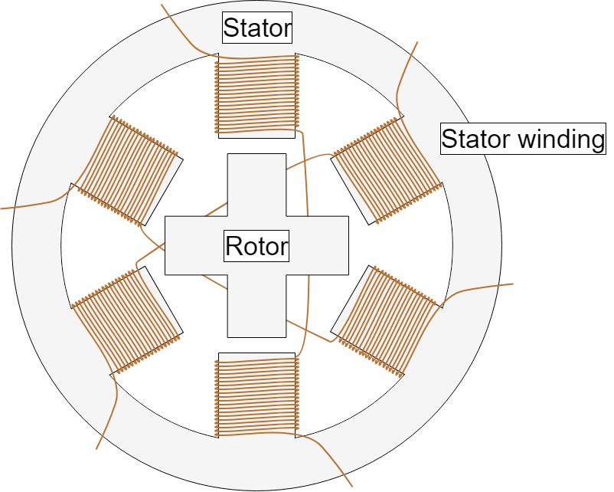

Figure 1: Cross-Section of a Stepper Motor

The basic working principle of the stepper motor is the following: By energizing one or more of the stator phases, a magnetic field is generated by the current flowing in the coil and the rotor aligns with this field. By supplying different phases in sequence, the rotor can be rotated by a specific amount to reach the desired final position. **Figure 2** shows a representation of the working principle. At the beginning, coil A is energized and the rotor is aligned with the magnetic field it produces. When coil B is energized, the rotor rotates clockwise by 60° to align with the new magnetic field. The same happens when coil C is energized. In the pictures, the colors of the stator teeth indicate the direction of the magnetic field generated by the stator winding.

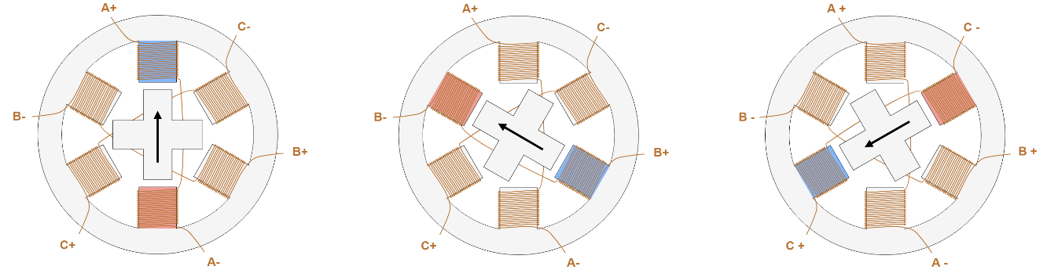

Figure 2: Stepper Motor Steps

**Stepper Motor Control**

We have seen previously that the motor coils need to be energized, in a specific sequence, to generate the magnetic field with which the rotor is going to align. Several devices are used to supply the necessary voltage to the coils, and thus allow the motor to function properly. Starting from the devices that are closer to the motor we have:

* + A transistor bridge is the device physically controlling the electrical connection of the motor coils. Transistors can be seen as electrically controlled interrupters, which, when closed allow the connection of a coil to the electrical supply and thus the flow of current in the coil. One transistor bridge is needed for each motor phase.
  + A pre-driver is a device that controls the activation of the transistors, providing the required voltage and current, it is in turn controlled by an MCU.
  + An MCU is a microcontroller unit, which is usually programmed by the motor user and generates specific signals for the pre-driver to obtain the desired motor behavior.

**Figure 7** shows a simple representation of a stepper motor control scheme. The pre-driver and the transistor bridge may be contained in a single device, called a **driver**.

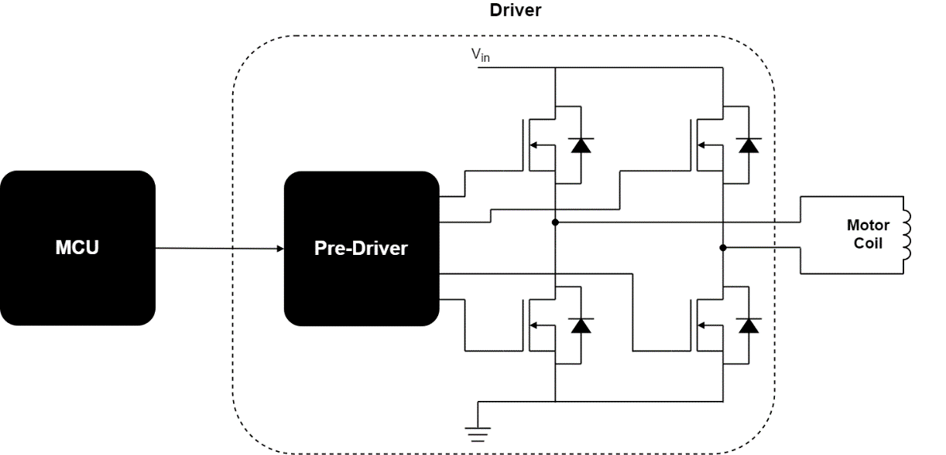

Figure 7: Motor Control Basic Scheme

### Stepper Motor Driver Types

There are different [stepper motor drivers](https://www.monolithicpower.com/en/products/motor-drivers/stepper-motor-drivers.html) available on the market, which showcase different features for specific applications. The most important charactreristics include the input interface. The most common options are:

* Step/Direction – By sending a pulse on the Step pin, the driver changes its output such that the motor will perform a step, the direction of which is determined by the level on the Direction pin.
* Phase/Enable – For each stator winding phase, Phase determines the current direction and triggers Enable if the phase is energized.
* PWM – Directly controls the gate signals of the low-side and high-side FETs.

Another important feature of a stepper motor driver is if it is only able to control the voltage across the winding, or also the current flowing through it:

* With voltage control, the driver only regulates the voltage across the winding. The torque developed and the speed with which the steps are executed only depend on motor and load characteristics.
* Current control drivers are more advanced, as they regulate the current flowing through the active coil in order to have better control over the torque produced, and thus the dynamic behavior of the whole system.

### Unipolar/Bipolar Motors

Another feature of the motor that also affects control is the arrangement of the stator coils that determine how the current direction is changed. To achieve the motion of the rotor, it is necessary not only to energize the coils, but also to control the direction of the current, which determines the direction of the magnetic field generated by the coil itself (see **Figure 8**).

In stepper motors, the issue of controlling the current direction is solved with two different approaches.

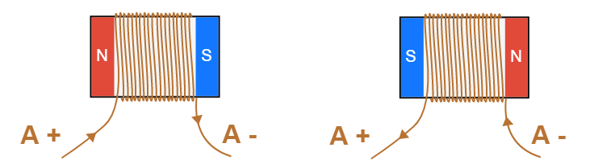

Figure 8: Direction of the Magnetic Field based on the Direction of the Coil Current. In **unipolar stepper motors**, one of the leads is connected to the central point of the coil (see **Figure 9**). This allows to control the direction of the current using relatively simple circuit and components. The central lead (AM) is connected to the input voltage VIN (see **Figure 8**). If MOSFET 1 is active, the current flows from AM to A+. If MOSFET 2 is active, current flows from AM to A-, generating a magnetic field in the opposite direction. As pointed out above, this approach allows a simpler driving circuit (only two semiconductors needed), but the drawback is that only half of the copper used in the motor is used at a time, this means that for the same current flowing in the coil, the magnetic field has half the intensity compared if all the copper were used. In addition, these motors are more difficult to construct since more leads have to be available as motor inputs.

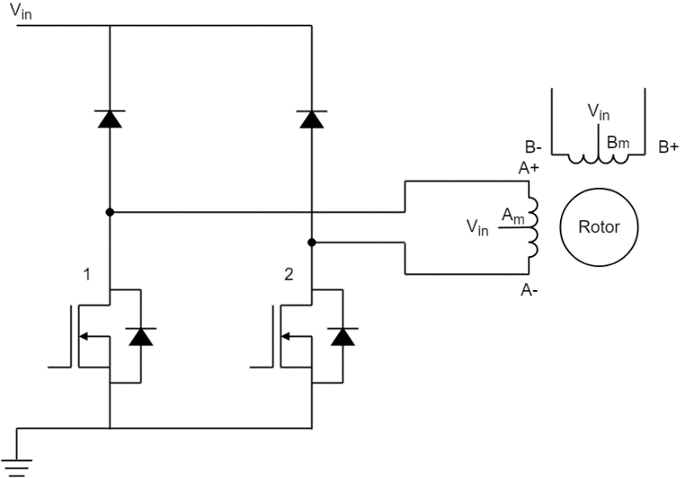

Figure 9: Unipolar Stepper Motor Driving Circuit

In **bipolar stepper motors**, each coil has only two leads available, and to control the direction it is necessary to use an H-bridge (see **Figure 10**). As shown in **Figure 8**, if MOSFETs 1 and 4 are active, the current flows from A+ to A-, while if MOSFETs 2 and 3 are active, current flows from A- to A+, generating a magnetic field in the opposite direction. This solution requires a more complex driving circuit, but allows the motor to achieve the maximum torque for the amount of copper that is used.

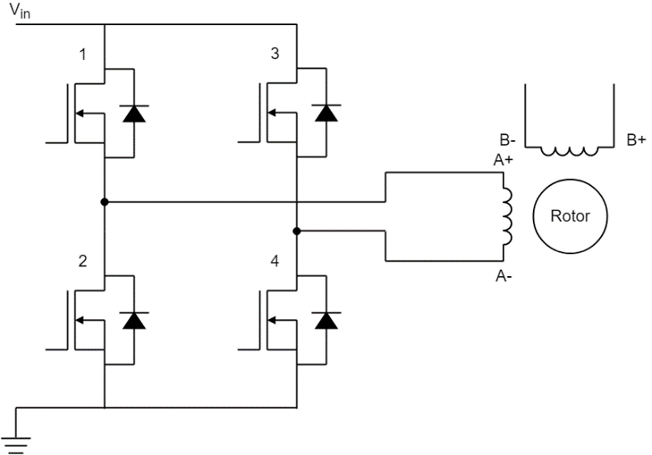

Figure 10: Bipolar Stepper Motor Driving Circuit

With technology progress, the advantages of unipolar are becoming less relevant, and [bipolar steppers](https://www.monolithicpower.com/en/support/videos/stepper-motor-driver-from-mps.html) are currently the most popular.

**Stepper Motors Advantages and Disadvantages**

**Advantages**

* Due to their internal structure, stepper motors do not require a sensor to detect the motor position. Since the motor moves by performing “steps,” by simply counting these steps, you can obtain the motor position at a given time.
* In addition, stepper motor control is pretty simple. The motor does need a driver, but does not need complex calculations or tuning to work properly. In general, the control effort is lower compared to other motors. With microstepping, you can reach high position accuracy, up to approximately 0.007°.
* Stepper motors offer good torque at low speeds, are great for holding position, and also tend to have a long lifespan.

**Disadvantages**

* They can miss a step if the load torque is too high. This negatively impacts the control, since there is no way to know the real position of the motor. Using microstepping makes stepper motors even more likely to experience this issue.
* These motors always drain maximum current even when still, which makes efficiency worse and can cause overheating.
* Stepper motors have low torque and become pretty noisy at high speeds.
* Finally, stepper motors have low power density and a low torque-to-inertia ratio.

To summarize, stepper motors are good when you need an inexpensive, easy-to-control solution and when efficiency and high torque at high speeds are not necessary.

Stepper Motor Uses and Applications

Due to their properties, stepper motors are used in many applications where a simple position control and the ability to hold a position are needed, including:

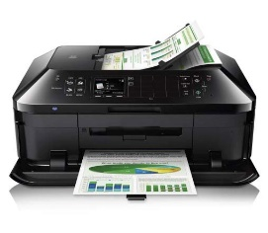 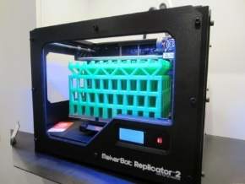

Printers: Printheads, Paper Feed, Scan Bar 3D Printers: XY Table Drive, Media Drive

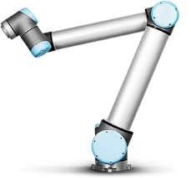 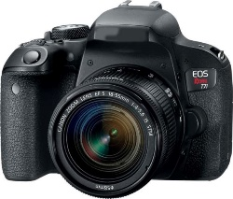

Robots: Arms, End Effector DSLR Cameras: Aperture/Focus Regulation

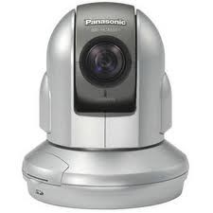 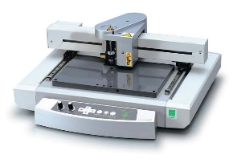

Video Cameras: Pan, Tilt, Zoom, Foc Engraving Machines: XY Table Motion

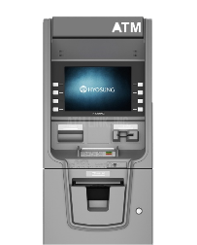

ATM Machines: Bill Movement, Tray Elevators

**Steps per Revolution** **= 360⁰ / Step Angle**  
For example, for **[Trinamic Motion Control GmbH](https://www.digikey.com/en/supplier-centers/trinamic)**[86](https://www.digikey.com/en/supplier-centers/trinamic), [**QSH4218-35-10-027**36](https://www.digikey.com/en/products/detail/trinamic-motion-control-gmbh/QSH4218-35-10-027/4843425), its step angle is 1.8⁰. So the number of steps per revolution = 360 / 1.8 = 200. This is a fixed relationship - all 1.8⁰ step angle stepper motors will have 200 individual steps. When selecting a stepper, choose a Steps Per Revolution figure or a Step Angle figure - not both.

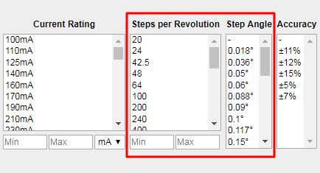

More steps per revolution shows that this stepper motor is able to move in smaller increments and thus control its position more precisely. Please note that more steps per revolution for stepper motors will cause those motors to rotate at a lower speed and provide lower torque than a similarly sized motor with fewer steps per revolution. Therefore, when looking for a high-precision stepper motor, the required speed and torque output for your application are essential to consider.

**INTERFACING PROGRAMS**

[Stepper - Arduino Reference](https://www.arduino.cc/reference/en/libraries/stepper/)

[Arduino and Stepper Motor Configurations | Arduino Documentation](https://docs.arduino.cc/learn/electronics/stepper-motors/)